Open Educational Resources Training Platform (OERTP)
User Manual
Release 1
Version 1

Raj Bharath Adamaram Seshadri
Intern at United Nations, Educational, Scientific and Cultural Organization (UNESCO)

Contents
The Purpose of this document 3
1.1 Introduction 3
1.2 Intended Audience and Reading Suggestions 3
1.3 Pre-requisites 3
1.4 Abbreviations 3
Registration to the OERTP 4
1.5 Register to the Website 4
1.6 Add Registration Page 4
1.7 User Roles / Authorization – Authentication 4
Manage Training Resources 6
1.8 Add a Training Resource 6
1.9 Edit the Training Resources 7
1.10 Deleting the Training Resources 7
1.11 Validate a Training resource 8
Manage Set of Categories 9
1.12 Add a Set of Category 9
1.13 Edit a Set of Categories 10
1.14 Deleting the Set of Categories 11
Manage Category 14
1.15 Add a Category 14
1.16 Edit the Category 15
1.17 Deleting a Category 16
1.18 Creating a Sub – Category 16
1.19 Suggest a Category 17
1.20 Validate a Category 18
Manage Comments 20
1.21 Post Comments 20
1.22 Validate Comments 22
1.23 Delete a Comment 23
Manage Review 25
1.24 Add a Review 25
1.25 Update the Reviews 26
1.26 Delete a Review 27
Manage Ratings 30
Administration Tools 31
1.27 Training Resources, Reviews and Comments 31
1.28 Other Admin Tasks 31
Drupal Administration Tasks (Only for Drupal admin) 42

The Purpose of this document

Introduction
This user manual provides the details about the expandable set of features in the Online Educational Resource Training Platform.

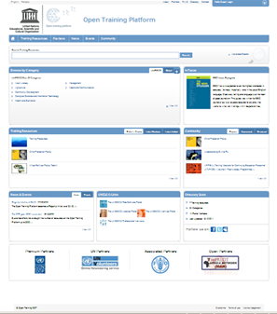

Intended Audience and Reading Suggestions
The intended audience of this document is (1) the customer(s) who commissioned development of the product, or (2) any active member of UNESCO OERTP team who is responsible for the administration of the software.

Pre-requisites
The required documents has been read and required tasks completed by the administrator to be able to proceed with the tasks defined in this manual for the customer and the UNESCO OERTP members.

Abbreviations
UNESCO United Nations, Educational, Scientific and Cultural Organization
OERTP Open Educational Resources and Training Platform

Registration to the OERTP

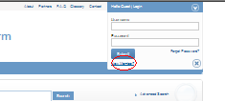
Register to the Website
The User has to register to the OERTP site filling the required information. It is administrator who will assign roles to the “User. By” default the system will make the User in the Member Groups.

Add Registration Page
The Guest User has to fill in the required information and save the form. After the Registration the Guest User becomes a Member in the OERTP and can access the application using his credentials which is sent to the Guest user by an email.

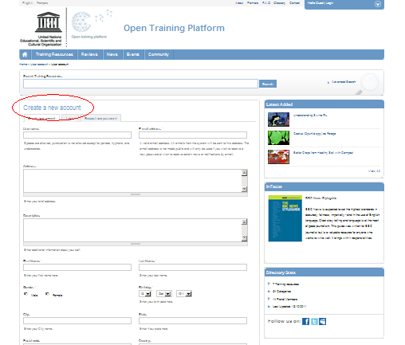

User Roles / Authorization – Authentication
There are 5 different types of registered users based on different profiles/roles. They are Administrator, Partner, Editor, Member and Reviewer. Partners are further classified as certified partners and non-certified partners. It is administrator who has the rights to assign roles to the registered Users.

Manage Training Resources
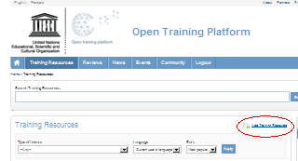
The Registered user can click on the Add Training Resources link in the Training Resouces page. The User can create, update, delete, validate and view the Training resources in the Online Educational Resource and Training Platform.

Add a Training Resource
The Registered User has to fill in all the necessary required information in the page. The User has to fill in all the mandatory fields to save the New Training Resources to the system (Refer the Appendix V in the SRS for all the fields requirements). The User has to associate General Set of categories to the Training resources the Categorization to the UNESCO categories is optional .The User can associate the Training Resources with the other member categories or with the Own User Defined categories. The Training Resources will be sent for Validation, once it is validated by the Administrator it will be visible in the system to all the other User.
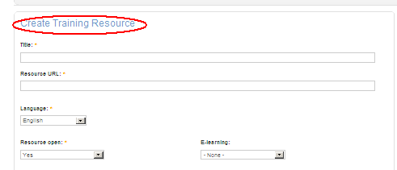

Edit the Training Resources
The User can edit the Training Resources (All Authorized Users according to the Authorization Matrix can edit a Training Resources) . The Member User can edit only their own resources. Clicking on the Edit button will open the Training Resources in a Editable mode. After editing the User can save the changes done which also be sent for approval to Administrator and once it is validated all the changes will be shown in the system for other users.

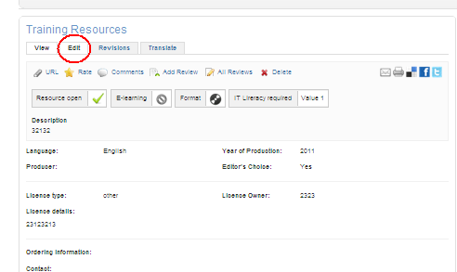

Deleting the Training Resources
The User can delete the Training Resources from the OERTP. But if the User is a Member or Non-Certified Partner, then the request for deletion will be sent to the Administrator. If the same is a User other than the Member or Non-certified Partner then the system will delete the Training Resources. After deleting it will remove all the association done with the Categories by the User.
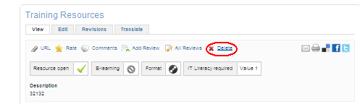

Validate a Training resource
All the Users according to the Authorization matrix can validate the Training Resource. The Training Resource is sent for validation when created. Updated or deleted by a user having a role of Member or non-certified Partner. Once the following actions are done, the system sends an notified email to the authorized user for validating the Training Resources. The Training Resources can either be rejected or validated by the User. Once The User validates then the training resources will be visible to all the other user in the Online Educational Resource and Training Platform. After the actions of users of validation and rejecting an email will be sent stating whether the Training Resources has been rejected or validated. Please see the screenshot below for reference.

Click on the administrative tools link from the right hand side of the page

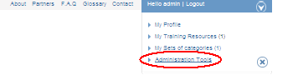
Click on the approve pending resources link

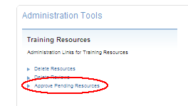
There will be Training Resources shown which are pending for approvals. The user can select the training resources and can either reject or validated the training resources
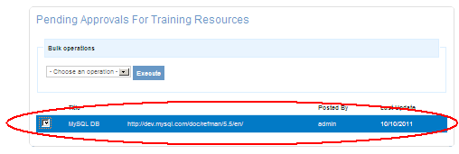

Manage Set of Categories
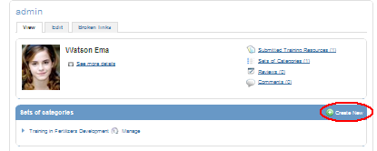
The User can click on the Submit New Link in the User Profile Page and create a New Set of Categories. The User can create, update and Delete the Set of categories in the Online Educational Resource and Training Platform.

Add a Set of Category
The User can create a New Set of Categories. All the Authorized user according to the Authorization matrix can create a New Set of categories. The User has to fill in all the mandatory field to save the Set of Categories to the system. Once the User has created, it will be displayed only to the User since it will be created as a User Defined Set of Categories. The Administrator has the rights to edit the Added Set of categories into a UNESCO or a Gobal Set of categories. Once it is changed to any of the following it will be visible to all the Other Users.

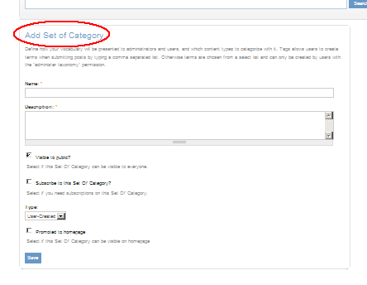

Edit a Set of Categories
The User can edit the Added Set of categories in the Online Educational Resource and Training Platform. The User has to click on the Manage link to open the Set of categories view page. Then the User can click on the Edit link and edit the Set of categories. The Modifications done by the User will not be sent for any validation to the administrator since the User is editing the User defined Set of categories.

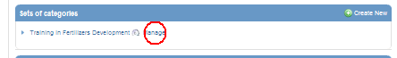
↓
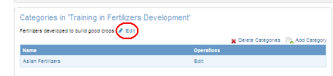

Deleting the Set of Categories
The User can delete the Set of categories from the Online Educational Resource and Training Platform. The Administrator has the multiple delete options for UNESCO / Global Sets of categories only. If the sets of categories requested for deletion are associated with certain training resources then after deletion the system will remove the association with training resource. If the sets of categories already have categories associated. After deletion, those categories are no longer associated with the deleted sets of categories. Please see the screen shots below for reference.

Deleting a UNESCO/Global Set of Categories (Only Admin can delete UNESCO/Global Set of categories)

Click on the administrative tools link from the right-hand-side of the page

Click on the Administer UNESCO Sets / Administer Global Sets link
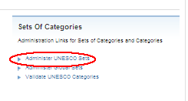
Click on the Delete Sets of Categories link
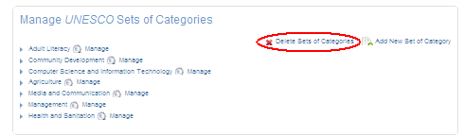
The User can select the Sets of categories to be deleted and then click on the Delete Sets of Categories Button
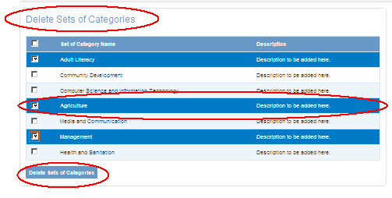

Deleting User Defined categories (The User can delete his own sets of categories from the User Profile page)

↓
↓
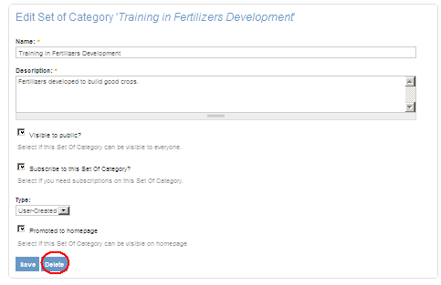

Manage Category
The User can create a new Category under his Own Sets of Categories. All the User according to the Authorization Matrix can create a category in the Online Educational Resource and Training Platform. The User can create, update and delete a category in the Online Educational Resource and Training Platform.

Add a Category
The User can create a Category in the Online Educational Resource and Training Platform. All the Authorized user according to the Authorization matrix can create a Category. The User have to Create the Category by going through the Manage link of Set of Categories, by which the when the User creates a New Category the system will associate it the Set of categories. The User can only associate category to his own sets of categories. The User has to fill in all the mandatory fields to save the category to the system

Click on the manage link

↓
Click on the Add category link

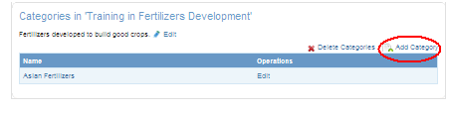
↓
After Clicking on the Add Category link , the system will open the Add category page

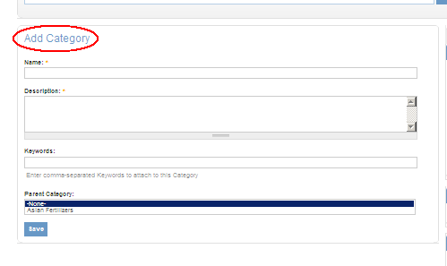

Edit the Category
The User can edit the Category in the Online Educational Resource and Training Platform. All the authorized User according to the Authorization matrix can edit a category .The User can update categories belonging to their Own Sets of Categories. After doing the changes, the User can save the modifications to the system. The User has to fill in all the mandatory fields while editing the Category.

Click on the Edit link

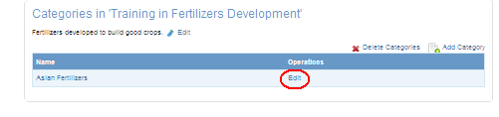

Deleting a Category
The User can delete the category from the Online Training Platform. The user can select one of more categories for deletion. If the categories requested for deletion are associated with certain training resources then after deletion the system will remove the association with training resource. If the sets of categories already have categories associated. After deletion, those categories are no longer associated with the deleted sets of categories.

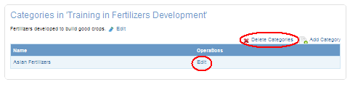
The image above shows the options where the User can do multi delete. The User can also click on the Edit link and can delete the category from the Online Educational Resource and Training Platform.

Creating a Sub – Category
The User can create a Sub category to the added Category in the Online Educational Resource and Training Platform. The User have to open the Add Category Page and fill in all the mandatory field and select the category in the Parent Category box for which the User wants the category to be created as a Sub- Category. Once the User saves the Page, the category will be created as a Sub category. Please see the screenshots below for reference.
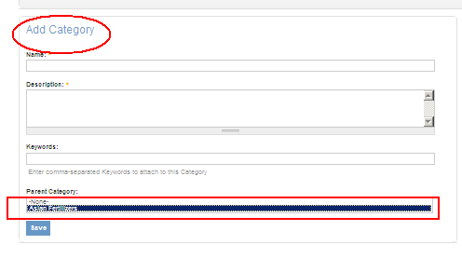
↓
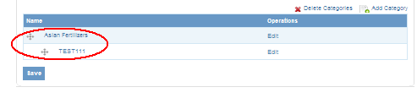

Suggest a Category
The User can suggest a category to the Administrator. The User will get link when the User is viewing any UNESCO or Global categories. Any registered user can suggest Category to the UNESCO or Global sets of categories. Once the category is suggested it will send for validation to the Administrator. The suggested category can only be associated to UNESCO or Global sets of categories. Please see the screenshots below for reference

Click on the Suggest new category link
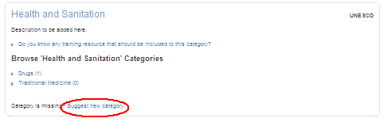
↓
The system will open the Suggest category page where the user can fill in all the necessary details.
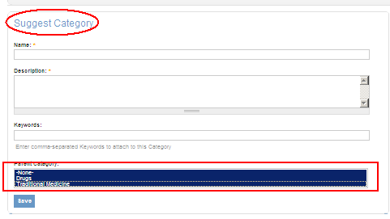
The suggested category can be associated to more than one sets of categories. The Categories can also have a sub categories. The suggested category will be visible to all the users only when the Administrators validates and approves the suggested category.

Validate a Category
All registered User can validate a Category .The User can suggest a category, once the User suggests the category it is sent for validation to the authorized User. The authorized user who have the rights for validating the category will be notified by an email. The User can either reject or validated the category. Once the validated it will be visible to all the Other User in the Online Educational Resource and Training Platform. Please see screenshots below for reference

Click on the administrative tolls link from the right-hand-side of the page

Click on the Validate UNESCO Categories link

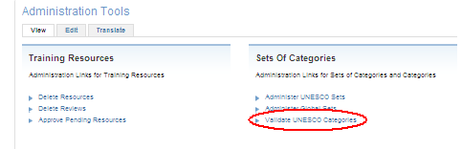

After clicking on the link the system will open the Validate category page where the User can select the category for rejection or validation. Once any of actions is done by the User a notified email is sent to the User who has given the suggestion stating whether the suggestion is validated or rejected.

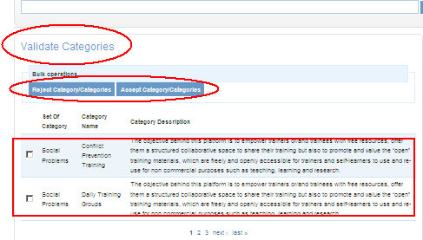

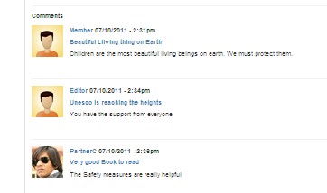
Manage Comments
The User can post comments on the Training Resources. All the Users according to the Authorization Matrix sheet can post comments on the Training Resources. The User can Post, Validate, Delete and View Comments.

Post Comments
Any Registered User can Post a comments on a Training Resources. The User can post a comment on the Training Resources by clicking on the Comments link. The User has to fill in the mandatory field to save the Comments to the Online Educational Resource and Training Platform. The Added comments by the User on a Training resources will not be seen to other User since when the User adds the comments it is sent validation to the authorized User. Please see the screenshots for reference
Click on the Comments link (The same if is an Guest User, he will get an Login and a Register link next to the Comments link)
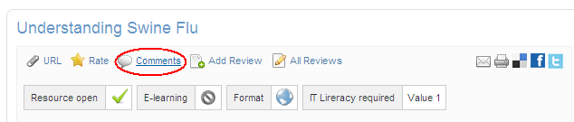

↓
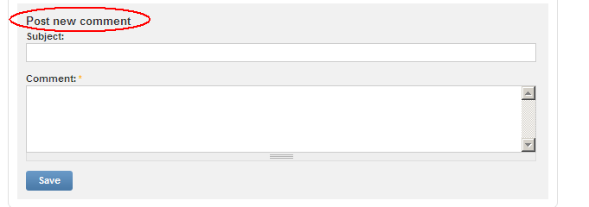
The User has to fill in the details and click on the save button to save the comments
↓
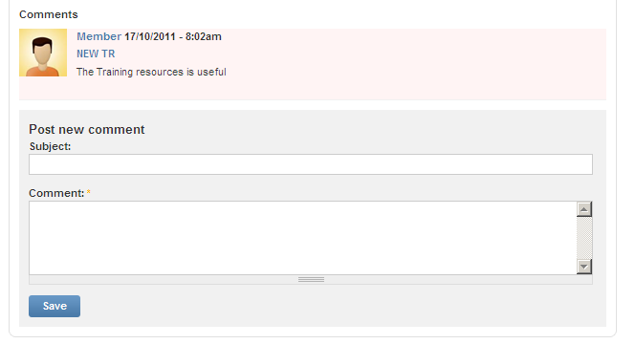
Once the User has added comments it will be visible in pink highlight and will not be visible to the Other Users. This states that the comments is not validated. The Posted comments will be visible to other users once it is validated by the Authorized users. The User cannot comment on his own Training Resources. The User can also reply to the training resources.

Validate Comments
The Posted comments by the Users are sent for validation. Editor and Administrator can validate comments. Once any User posts a comment a email is sent for approval to the authorized user for validation. The authorized user can validate the comment from the Training Resources page or from the Administrative tools options from the right hand side of the page. The Authorized users can either validate or reject the posted comments. Please see the screenshots for reference
Click on the administrative tolls link from the right hand side of the page

Click on the Approve / Delete Comments link
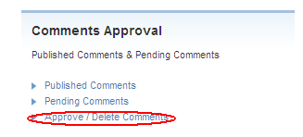
From the Approval page select the comment and then from the drop down select the action which needs to be performed i.e publish or Delete. After selecting the action click on the Update button
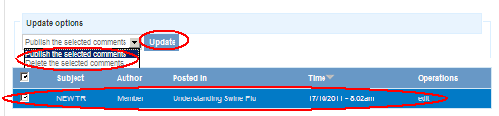

The User will be directed to the Approval page showing all the Approved Comments and an email will be sent to the user stating that the Comments has been validated. The User can also Un-publish the published comments by selecting the comments and then selecting the Un-publish option from the drop down and clicking on the Update button.
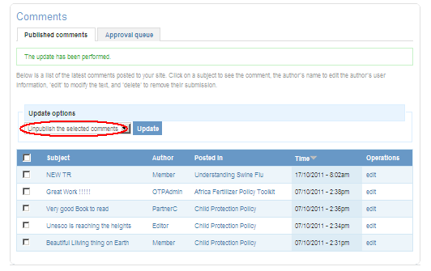

Delete a Comment
All the Authorized Users according to the authorization matrix can delete a comment. The registered user can delete only his own comments. The Administrator can delete the other User comments. Please see screenshots below for reference.
In the Training Resource Page click on the Delete link which is in the Comments section
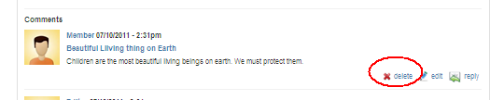

After clicking on the delete link , the system will ask for confirmation for Delete. Click on the Delete button . The comment will be deleted from the Training Resources.
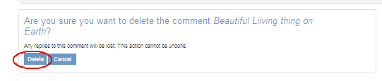
The administrator can also delete the comments from the Administrative tools from the right hand side of the page. Please see the screenshots below for reference
Click on the administrative tolls link from the right hand side of the page

Click on the Published Comments link
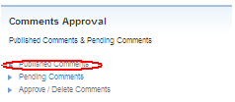
Now select the comments which needs to be deleted. Then select the Delete option from the drop down and click on the Update button. The comment will get deleted from the Training Resources

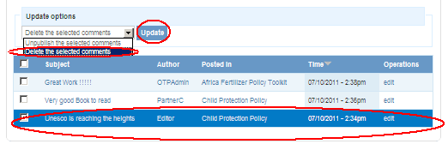

Manage Review
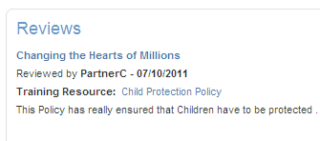
The Registered User can add Review for a Training Resources. All the authorized user according to the Authorization matrix can add a review to the Training Resources. The User can create, Update and Delete a review.

Add a Review
Any registered User can add a Review to the Training Resources .The User have to fill in the mandatory field to save the Review to the Training Resources. Please see the screenshots below for reference
Click on the Add Review Link in the Training Resources Page
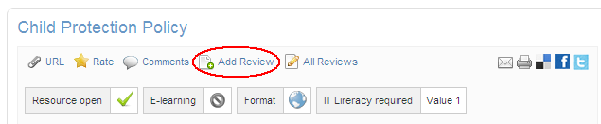
↓
Fill in all the required fields and click on the Save button to save the Reviews to the Training Resources
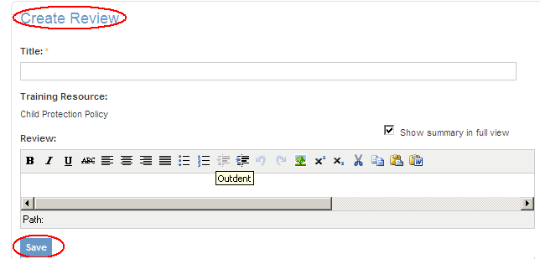

Update the Reviews
The User can edit the Reviews. All the registered user according to the authorization Matrix can edit the reviews. The User has to fill in the mandatory fields to save the changes to the Reviews in the Training Resources.

Click on the All Reviews link
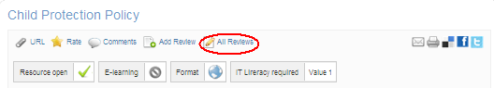
↓
Now click on the Review which you want to edit
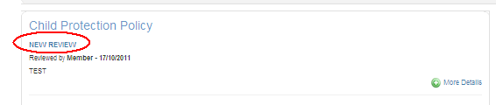
↓
After clicking on the Reviews, click on the Edit button which will open the Review in an editable mode. The User can modify the added content and save his changes to the Reviews.
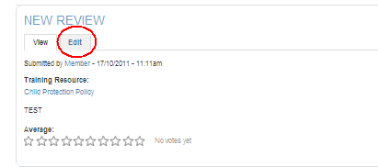
↓
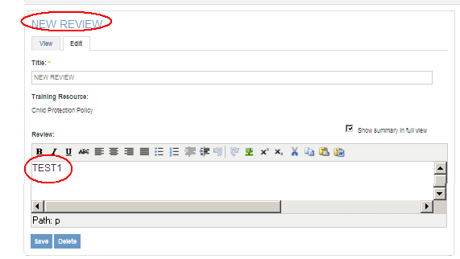

Delete a Review
All the registered User can delete a Review in the Online Educational Resource and Training Platform. The user can delete his own reviews only. Only the Reviewer and the Administrator can delete the other User reviews in the training resources. Please see the screenshots below for reference.
Click on the All Reviews link
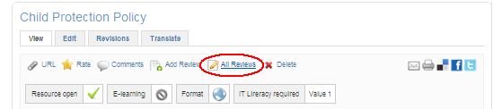
↓
Now click on the Review which you want to Delete
↓
After clicking on the Reviews, click on the Edit button which will open the Review in an editable mode. The User can either delete it from opening the review or from clicking on the Delete link.
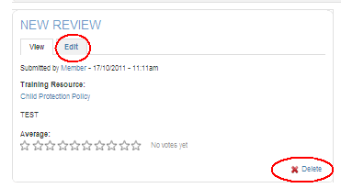
↓
From opening the Review
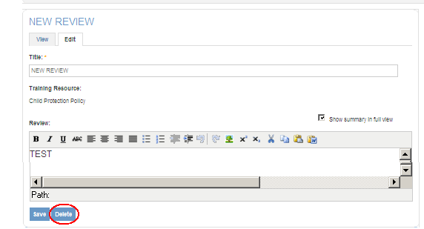
↓
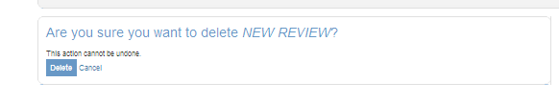
The system will ask for confirmation of Delete. Once the User click on the Delete button the Review will get deleted from the Training Resources. The Reviewer can delete the reviews from the Reviews Page which is accessible from the Reviews Tab in the Home Page.
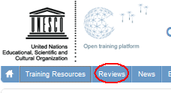

Manage Ratings
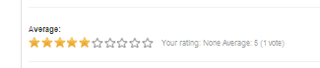
All the Registered User can Rate a Training Resources in the Online Educational Resource and Training Platform according to the Authorization matrix. The User cannot rate his own submitted Training Resources. The User can rate a Training resources any number of times. But the user can rate a Training Resource only once per month. The Training Resource can be rated with a rating varying from 1 to 10. The Ratings displayed after all the Users have rated is calculated as average value of all given ratings. Please see the screenshots below for reference

Click on the Rate link in the Training Resource Page
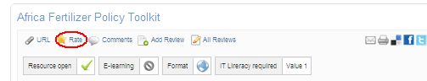
↓
The User have to rate the Training Resource
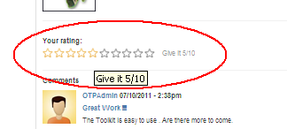
↓
After the rating are given the Rating will be displayed showing the average votes for the Training Resources
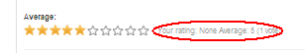

Administration Tools
Only the Admin and Editor roles have access to Administration Tools Section. This section provides links for managing various content on the site.

Training Resources, Reviews and Comments
- Approve Pending Resources
This page will list all newly added or updated resources that require verification. For each resource, the user can view the resource URL, the user who added/ modified the resource and the date the resource was modified. The user can then select the resource and click on “Publish” to approve the resource and publish it to all users on the system.
- Approve Deletion Resources
This page will list all resources that have been requested for deletion by its author. Similar to “Approve Pending Resource”, the user can select the resource and click on “Un-publish” to un-publish the resource and remove it from all listings.

Other Admin Tasks
- Execute Automated Process
This link executes the system’s background process that handles the following functionality:
- Search indexing: Indexes all new / updated content on the site for inclusion in the search results.
- Resource Link Checking: Verifies the link for each training resource and if it is broken, sends mails to its author, its category authors and administrators. It also un-publishes the resource.
- Follow-up messages to inactive members: Checks the last activity time for each member and sends required reminder emails. If member still does not respond, de-activates his/her account.
- Follow-up messages to member contributors: Follow-up messages to members who have added resources/ rated / commented or reviewed any resource.
- Pre-deletion warning message to never logged-in members: Checks for members who registered but did not login and sends reminder messages to each. If member still does not respond, deletes his /her account.
- Modify “In Focus” content
This link provides a page where admin / editor can modify the content to be displayed on the homepage under the “In Focus” block. One image can be added for display on the left side of the block. If no image is specified, the textual content will be shifted to the left. On the homepage, maximum 250 characters will be displayed. If the length of textual content is greater, then the content will be trimmed and a “Read More” link will be displayed on the homepage.

- Modify “Community Page” content
Similar to “In Focus”, this link provides a page where admin / editor can modify the content to be displayed on the Community Page under “Sets of Categories” section.

- Manage UNESCO Links.
This link provides a page where admin/editor can modify content to be displayed on the homepage under the “UNESCO Links' block. UNESCO Links content can be unpublished or deleted using this page. If admin / editor needs to update existing UNESCO link content then He needs to click on content title where on node page “view” & “Edit” options are present. Edit option will let you edit 1. Title 2. Image. 3. URL of UNESCO Links.

- Manage “Follow Us” Links
This link provides a page where admin/editor can modify content to be displayed on the homepage under the “Follow Us” block. Follow us content can be unpublished or deleted using this page. If admin / editor needs to update existing this content then He needs to click on content title where on node page “ view” & “Edit” options are present. Edit option will let you edit 1. Title 2. Image. 3. URL of
Social Networking.

- Translation Search
Translation Search functionality provides on search interface which is useful for searching particular word in all content.
For Example: if you search “contact” word into search box,
Search result will displayed like following page

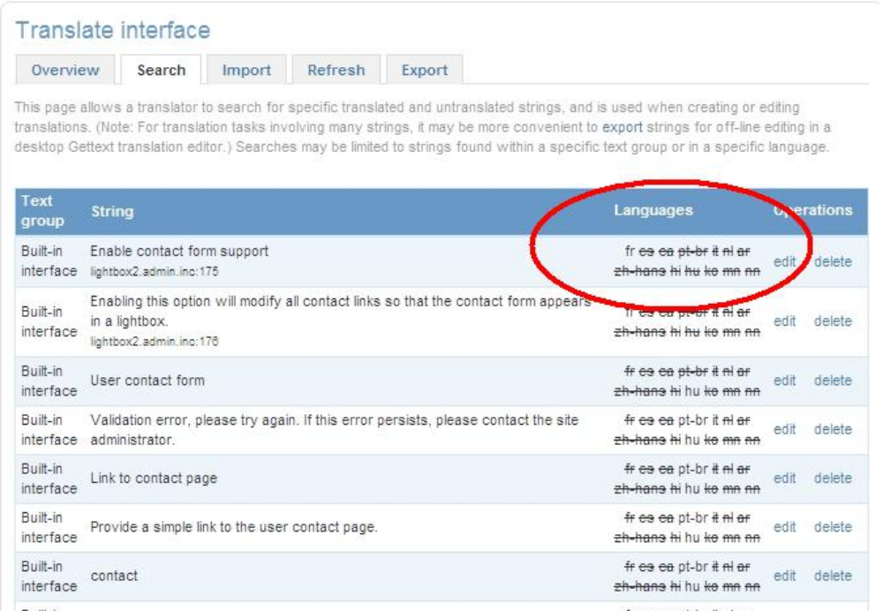
Here in this page admin/editor needs to edit the word translation by clicking on edit button
Save the translated word in following page.

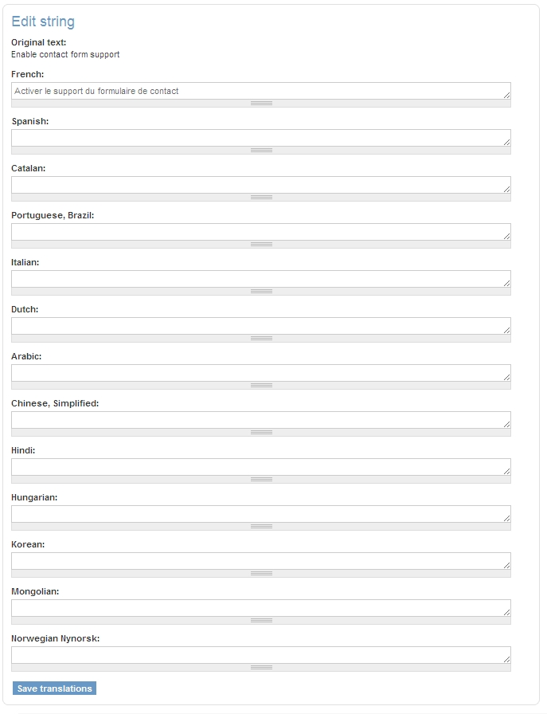

- Import Translation Files.
On the Import translation page admin/editor can import the .po file with corresponding language (Need to select in “Import into:” select box)

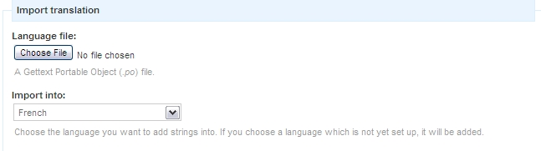

- Import Content
This link provides a page where admin/editor can import content form specified CSV format file. This process is little lengthy and needs extra attention.
Total 8 steps: Please follow the screen shots carefully.
1. Select “NEXT” on this page
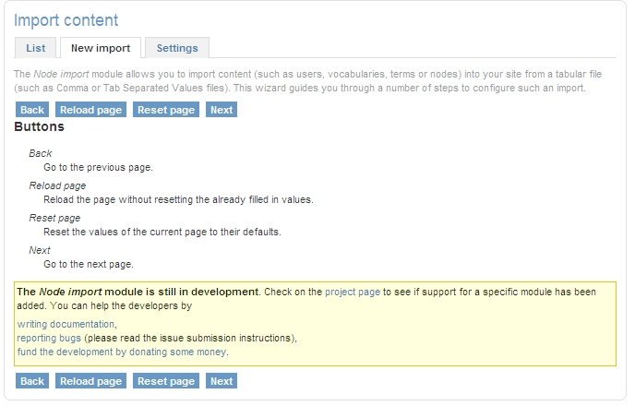

Step : 1
Select the Content type on this page (In this example we are selecting “Training Resource”) then click on NEXT button
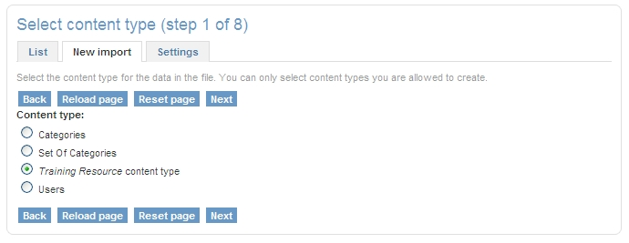
Step: 2
In this page user needs to select either from existing .csv file or user can upload new file by using upload file. Then click on NEXT button

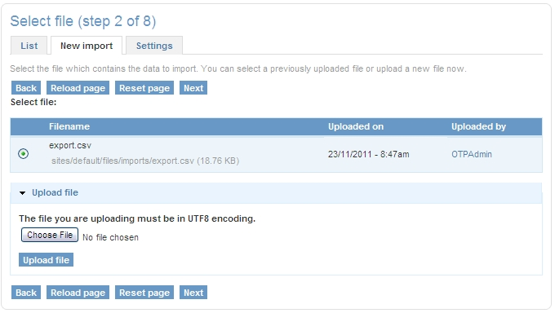

Step: 3
In this page user needs to map the CSV file setting from given option (ref: Screenshot). Then click on NEXT button
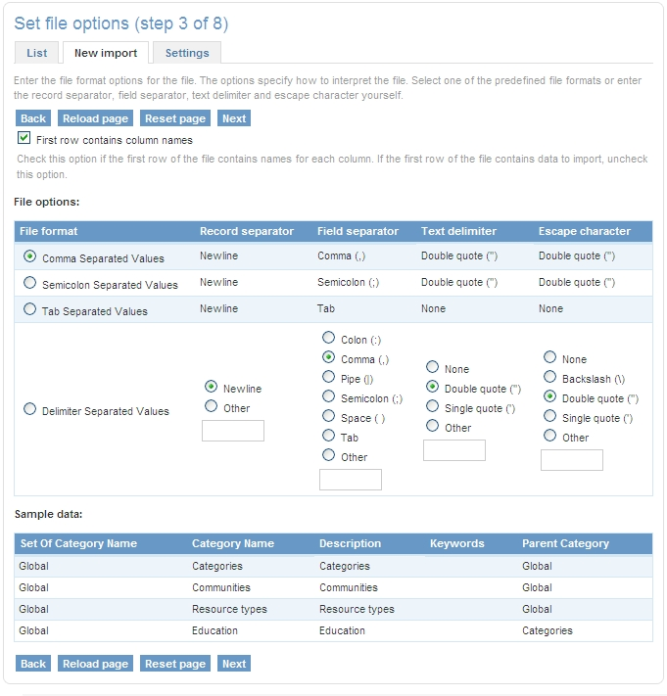
Step : 4
In this page user needs to map the CSV file columns from content type fields (ref: Screenshot). Then click on NEXT button

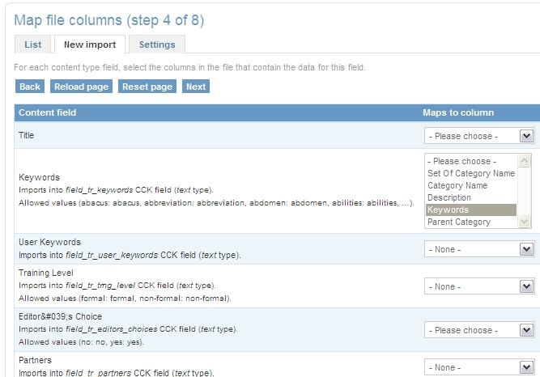
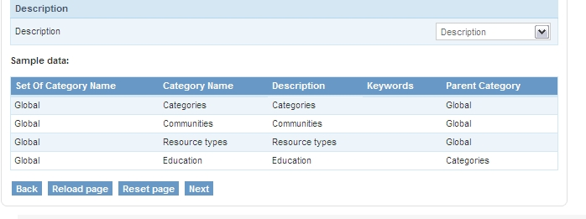

Step: 5
In this page user needs to map the CSV file custom field from content type fields (ref: Screenshot). Then click on NEXT button
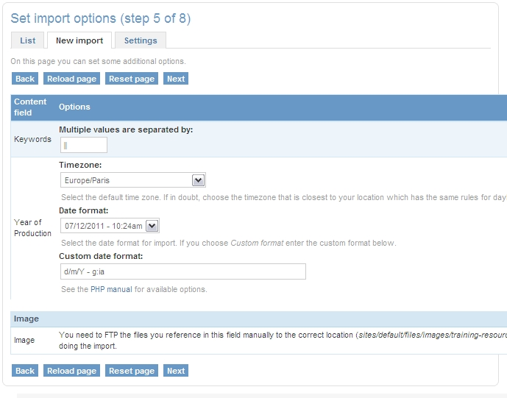
Step: 6
In this page user needs to map the CSV file with default values e.g. language (ref: Screenshot). Then click on NEXT button

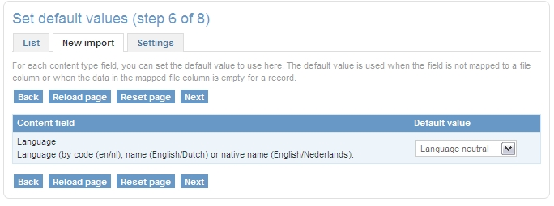

Step: 7
This page will provide you import preview .Errors also displayed on this page (ref: Screen shot). Then click on NEXT button
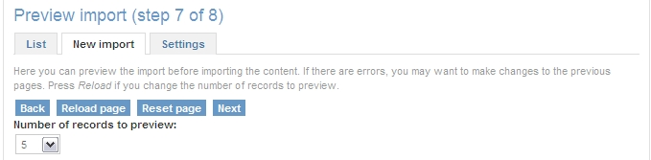

Step: 8
This page will provide you import preview .Actual import process start by clicking on START IMPORT (ref: Screen shot). Then click on NEXT button.
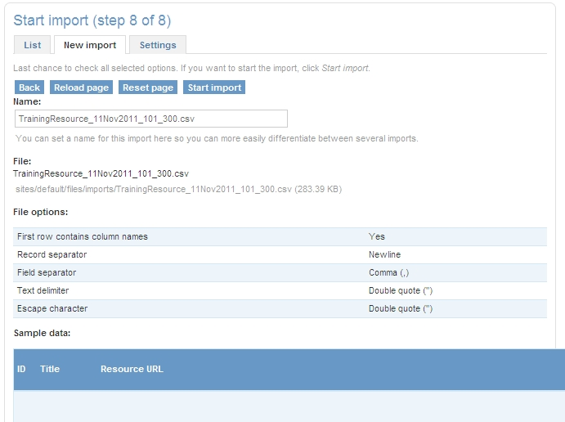

- Manage Users
From this page admin/editor can mange user.

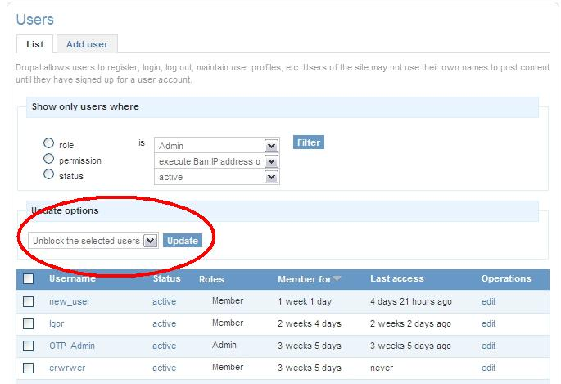
- Clear Unused keywords
This is functionality will clean unused keyword from system.

Drupal Administration Tasks (Only for Drupal admin)

1. Content type modifications
From admin menu (Black strip on top) you can manage all Drupal settings & configurations (Caution: This needs in-depth Drupal knowledge).
For example: we will modify contact filed in training resource so go to:
Content management>> Content type>> edit Training Resource >> manage field >> Contact
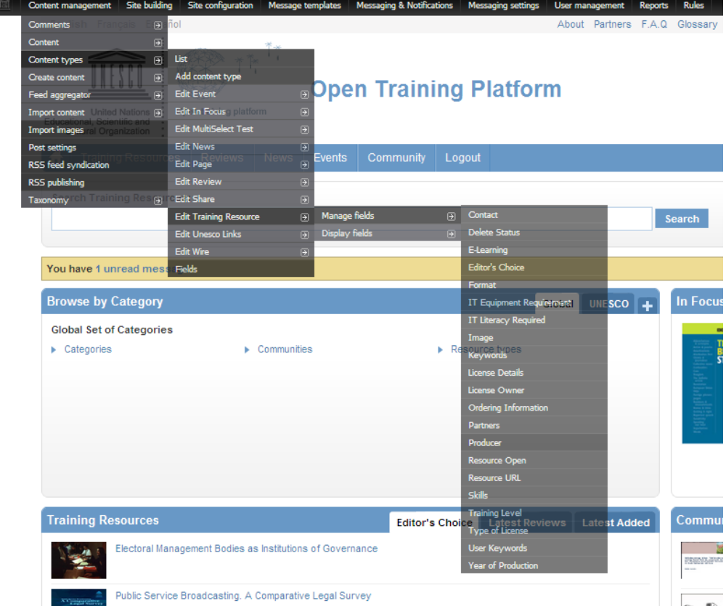
When user clicks in contact filed menu it will lead user to setting page where user can change the existing setting of this filed.

Please refer screen shot for contact setting.
